**Project Design Phase-II**

**Data Flow Diagram & User Stories**

|  |  |
| --- | --- |
| Date | 14 October 2022 |
| Team ID | PNT2022TMID42258 |
| Project Name | Project – Real Time communication System Powered by AI for Specially Abled |
| Maximum Marks | 4 Marks |

**Data Flow Diagrams:**

A Data Flow Diagram (DFD) is a traditional visual representation of the information flows within a system. A neat and clear DFD can depict the right amount of the system requirement graphically. It shows how data enters and leaves the system, what changes the information, and where data is stored.

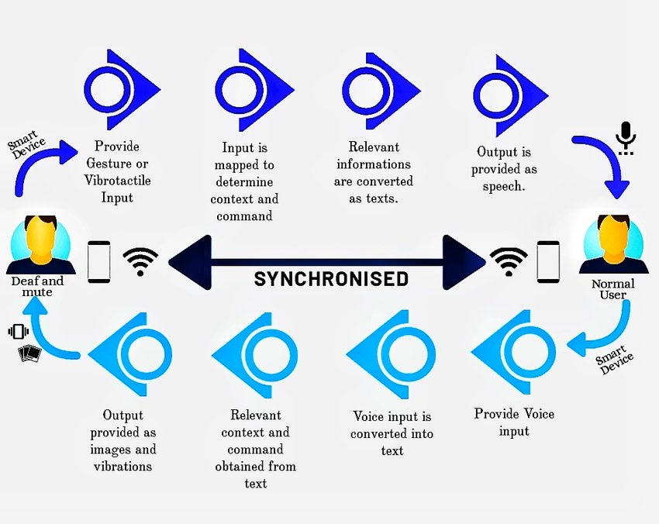

**User Stories**

| **User Type** | **Functional Requirement (Epic)** | **User Story Number** | **User Story / Task** | **Acceptance criteria** | **Priority** | **Release** |
| --- | --- | --- | --- | --- | --- | --- |
| Normal people and Deaf-mute people | Registration | USN-1 | As a user, I can register for the application by entering my email, and password, and confirming my password | I can access my account/dashboard | High | Sprint-1 |
|  |  | USN-2 | As a user, I will receive a confirmation email once I have registered for the application | I can receive a confirmation email & click confirm | High | Sprint-1 |
|  |  |  |  |  |  |  |
|  | Dashboard |  | Two options available    Choose the option based on who uses the app.  If you are normal person click the “normal people” option.  If you are deaf-mute people click “deaf-mute”  Option | I can access my dashboard | High | Sprint-1 |
| Normal people |  |  | Give access to camera to recognize the gestures  Give access to microphone to give our message through voice | I can access messages given by the Deaf-mute people | High | Sprint-1 |
| Deaf-mute people |  |  | Give access to display to view the message sent by normal people. | I can access messages given by the Normal people | High | Sprint-1 |